Research it! Human Dive Reflex? (Get your Physiologist On!)
Research Title: _____________________________________________
Choosing Variables: _____________________________________________________
(one manipulated/independent/input variable)
______________________________________________________________
(one responding/dependent/output variable)
1______________________________________________________________
2______________________________________________________________
3______________________________________________________________
(choose three controlled variables, or things
to keep identical for all trials of both treatments)
Research Questions: Do humans have a dive reflex?
Hypothesis/Prediction:
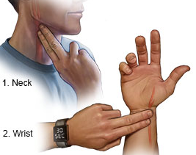
We predict that if we measure _______________________before and after submerging our noses in water then___________________________ __________________________________________ because _________________________________________
Procedure: 1. Let your partner measure your resting heart rate for 30 seconds by placing the pads of two fingers on the inside of your wrist by the hand or on the carotid artery on your neck. Fit Bits work, too! Record in the table below.

2. Fill a small, paper cup with ice water and submerge your nose in the water. It is okay to let it enter your nose but be careful not to breathe it in!
Again, have your partner measure your resting heart rate, but while your nose is under water. Try to hold your breath with your nose in the water for 30 seconds, if you can.
Record in the table below.
Results:
Team Member initials
Heart Rate in air (BPM)
Heart Rate with nose submerged

Graph your results: Have your Research Associate add your data to the class graph,
then make a graph here or in a spreadsheet on your computer.
- Label the axes: Write the items you compared on the horizontal x-axis. This is your manipulated or input variable. Write what you measured on the vertical y-axis. This is your responding or output variable.
- Number your y-axis. Use > half the graph and a scale that fits your whole value range.
- Choose the best graph type to most easily compare between orca types.

Heart rate (beats per minute)
_______________________

Initials ____________________ __________________ __________________ __________________
Human dive response test subjects

Discuss your findings with your class.

