Hungry Hungry Porpoise

Did you know? *What to do:
There is a harbor porpoise. It breathes air. It’s hungry. Its prey is in deep water where there is no light and no air.  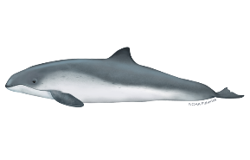 | Be the porpoise! Or its prey, or even an island in a game that is kind of like tag… in the dark… without air.  1. Select a classmate to be the porpoise. Don’t all jump at once  Discuss/look it up: What do harbor porpoises hunt for?  _______________________________________________________________________  2. Place the porpoise mask (blindfold) on the porpoise.  3. Select a classmate or 2 or 3 to be its prey. Have them select the type of prey they are representing in the game.  4. All other classmates become islands (boundaries) and form a loose circle in the playing area. Porpoise and prey must stay within the island boundary.  5. When the game begins, the porpoise will need to locate its prey.  Discuss/look it up: How do porpoises locate prey in the dark?  ______________________________________________________________________  6. When the blindfolded porpoise claps once, the prey clap twice. The porpoise must locate and catch (tag) them.  7. A round ends when at least one prey is caught, meaning the porpoise is full and happy, or 5 minutes goes by with no catch.  8. Play a few rounds this way, then make it a little more realistic:  The porpoise has to hold its breath while hunting. When he/she must come up for air (breathe), another porpoise takes its place!

