Activity! Hydrodynamics-Model diving animal speed tournament

Diving mammal shapes help them slide through the water. Here are a few (from what-when-how.com ) | 1. Gather water-resistant modeling clay for each Explore Team member.  2. Make a model of a fast-diving marine animal using your clay.  3. Race your Explore Team! Time a dive from the surface to the ‘prey’ at the bottom of a tank of water.  4. Winners from each Explore Team have a dive-off.  5. Track winning divers using the tournament brackets on the next page.
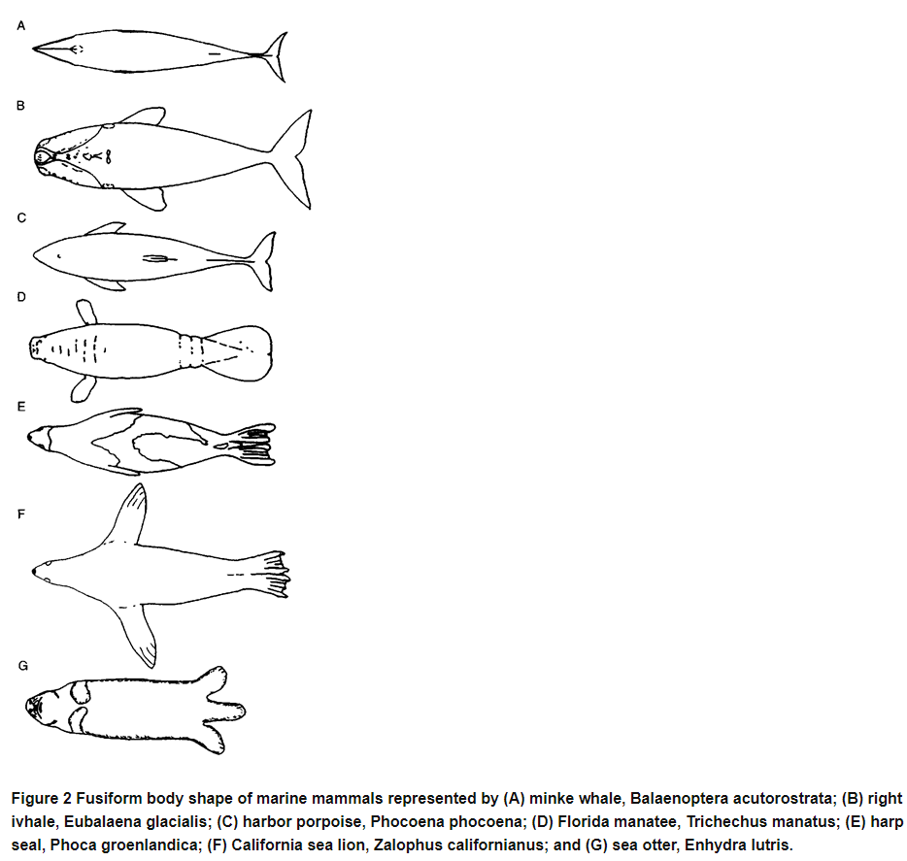
*Did you know? *What to do:

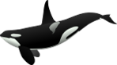
Speed Diving Tournament
