1. Salinity
The saltiness of sea water

Salinity is measured in # parts salt in
1000 parts water:
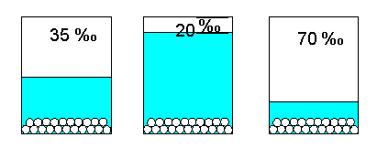
utdallas.edu
- Tidepool water could evaporate = salinity
- Rain could fill up tidepools = salinity

Your job:
1. Choose one intertidal organism and act it out (charades style).

2. Share one adaptation it might have to keep from losing water in a salty pool, or soaking up too much water (bloating) in a rain-filled pool?

2. Temperature
A measure of the kinetic energy of the particles in a substance. The KE is what causes how hot or cold something is.

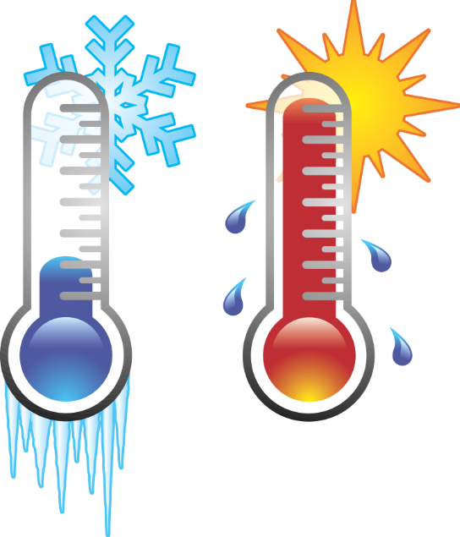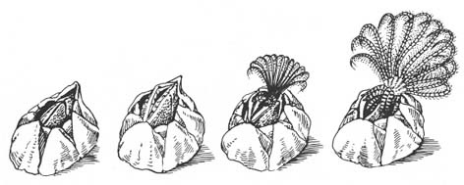
worldartsme.com waterwereld.nu
An organism’s metabolism (heart rate, breathing rate, and rate of digestion) may speed up when temperature warms up and slow down when it cools.

Your job:
1. Choose one intertidal organism and act it out (charades style).

2. Share one adaptation it might have to stay cool when it’s hot or keep from freezing in winter cold?

3. Drying out
An organism that needs to stay wet to live may be left high and dry when the tide goes out or the tide pool dries up.
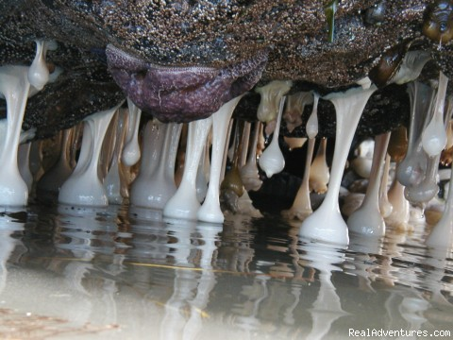

Your job:
1. Choose one intertidal organism and act it out (charades style).

2. Share one adaptation it might have to keep moisture inside when it is out of the water?

4. Sunlight
The sun’s intense rays can burn sensitive sea creature skin.
sunnydayskyimages
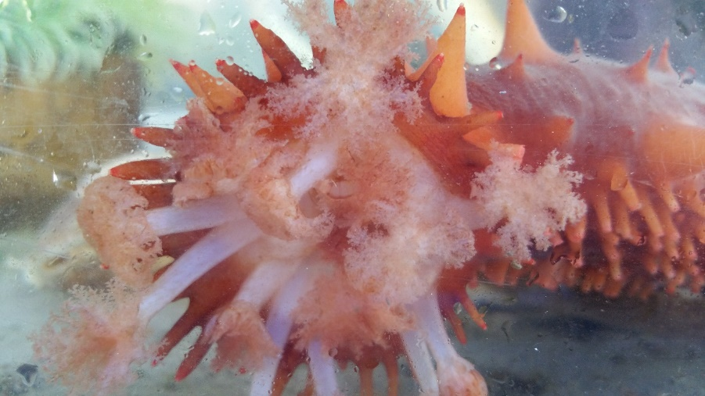

Mira

Your job:
1. Choose one intertidal organism and act it out (charades style).

2. Share one adaptation it might have to protect its skin from sun?

5. Wind
Light wind can dry out an organism fast and strong wind can blow them off the rocks.
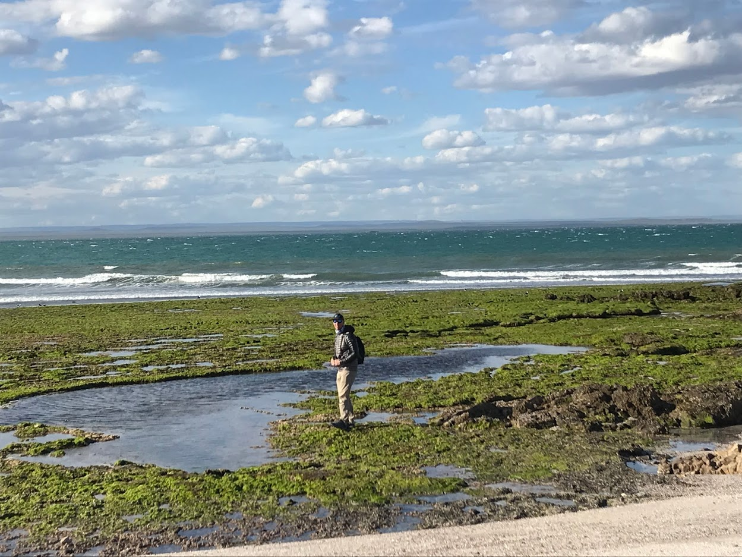
Photo of Joe Gaydos by Markus Naugle

Your job:
1. Choose one intertidal organism and act it out (charades style).

2. Share one adaptation it might have to keep from drying out or getting blown away by the wind?

6. Waves
Wind causes waves:
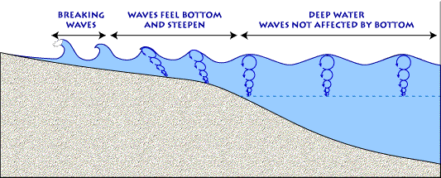USGS
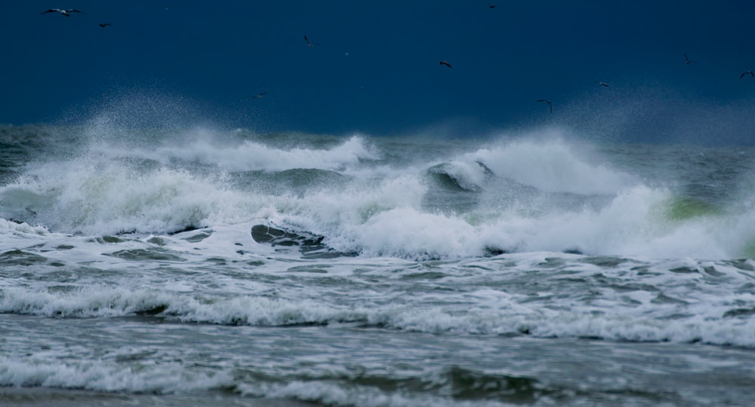Barth Bailey

Your job:
1. Choose one intertidal organism and act it out (charades style).

2. Share one adaptation it might have to keep from getting smashed or swept away by waves?

7. Predators
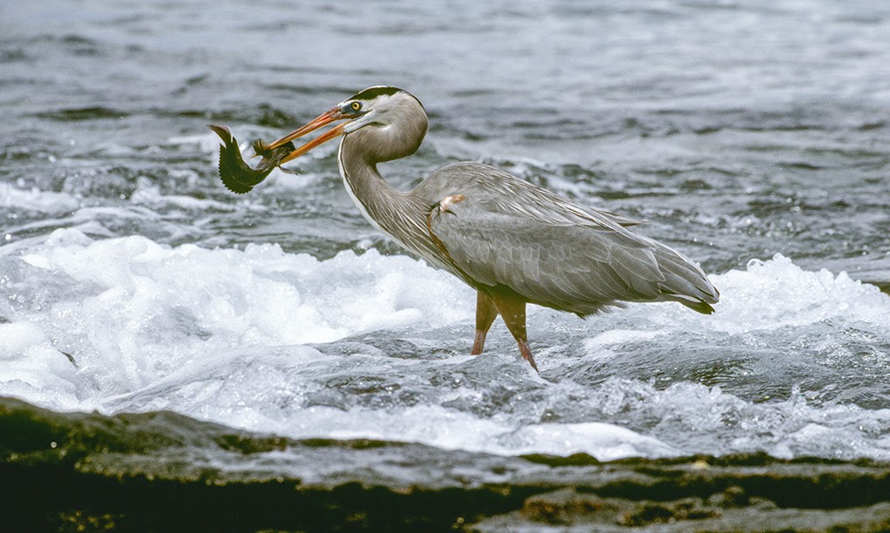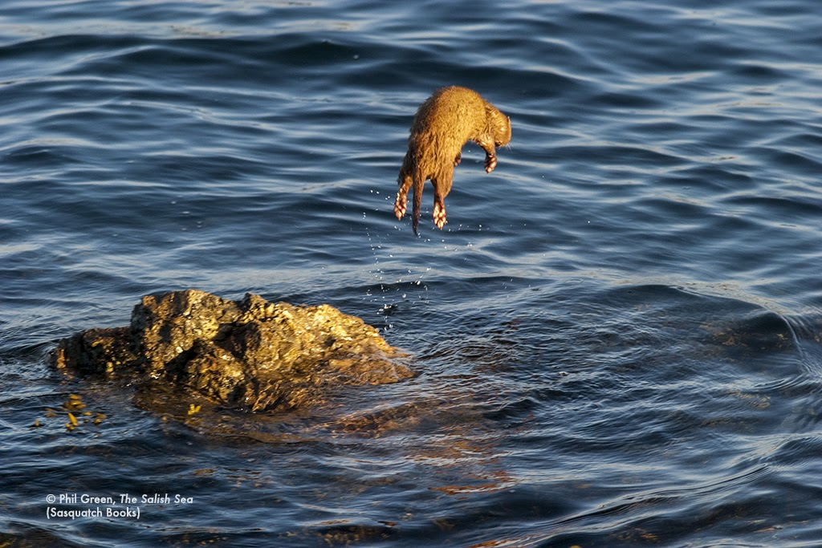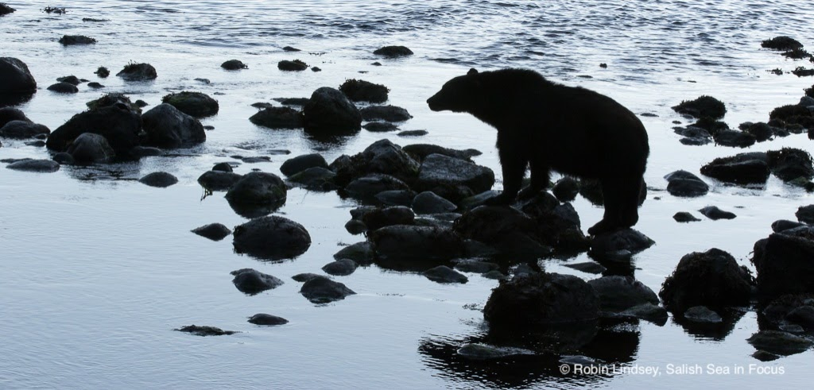
Herons and minks and bears, oh my!

Your job:
1. Choose one intertidal organism and act it out (charades style).

2. Share one adaptation it might have to avoid getting stabbed, snatched, pried off, crunched, or drilled into by predators?

8. Salish Sea Explorers
Sometimes people trample, poke, hold, or contaminate living things in the intertidal. Even if it is not on purpose, it can still do some damage, like crushing anemones or mussels, or breaking the protective mucus layer on fish.
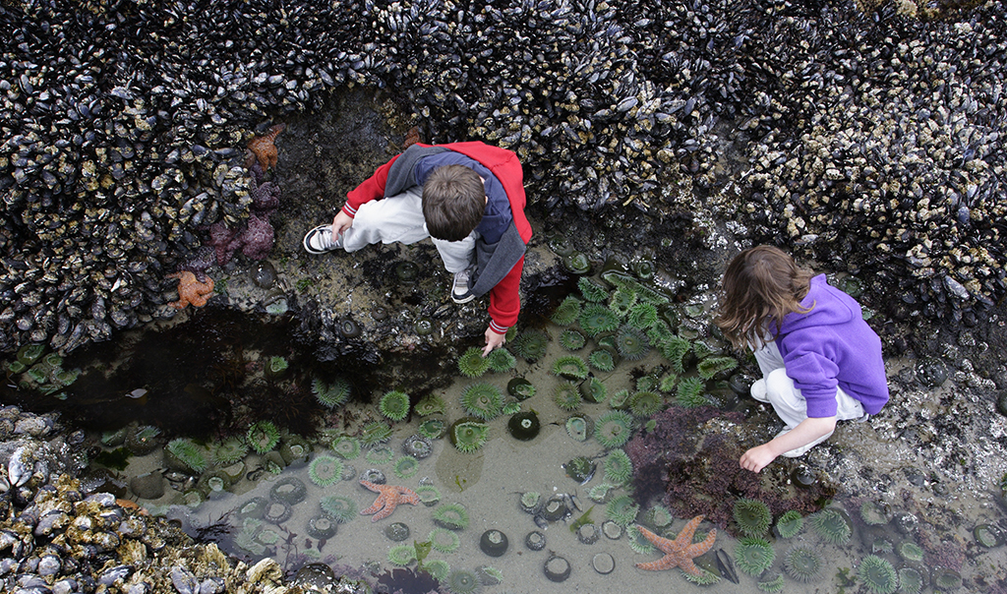

Your job:
1. Choose one intertidal organism and act it out (charades style).

2. Share one strategy YOU could use to keep intertidal neighbors safe while you explore.

