MODEL A WATERSHED
BACKGROUND FOR PEER PRESENTERS
What is a watershed? All of the land and waterways from the ridge crests, hillsides, and valleys that deliver rainwater and snow melt to one estuary far and away below make up one watershed. As you probably guessed, we all live in a watershed. The way we live and choices we make every day affect the wildlife and their habitats in the watershed, including the sea below. This flow of water downhill is one way that the land and sea are connected. They are connected by streams, rivers, and run-off from city streets and farmlands.

People usually learn best through hands-on discovery. Help your students to model a watershed, then make it rain to watch how water travels through it to the bay below. As water travels over land, it can wash terrestrial contents downstream, including dirt, detritus, nutrients, and things that humans spill or leave in the watershed. Substances on hard surfaces, like asphalt, wash into streams even faster. Show the class just how this delivery might look!

MATERIALS
For each person: 1 watershed activity packet.
For each pair: 1 laptop or tablet with internet connection
For the model:
- 1 large, waterproof bin, such as a shallow roasting pan or shallow, plastic storage bin
- 1 sheet of poster paper, crumpled into a ball, then stretched and the edges taped to the inside edges of the waterproof bin.
- Blue, brown, green, and gray watercolor markers for drawing in where water would likely gather (blue), where there are logging or construction sites (brown), and where there is pasture (green), and where streets might be (gray). Draw these ahead of time.
- One small container of each of the following:
*Coffee grounds = cow manure  *Red Jell-O = industrial waste  *Fine dirt = eroded sediments from construction site  *Miniature figurines, 1-3 of each: cows, dogs, trees, houses, cars, factory, excavator, bulldozer, cars, boats, ships, fences, plants  *Orange Jell-O powder = fertilizer/herbicide | *Instant coffee = pet waste  *Powdered milk = suds from washing cars  *Hot cocoa mix (mix with water on morning of activity) = motor oil  *1” x 2” green felt strips = turf (vegetation to prevent erosion and absorb runoff)  * 2 spray bottles with water = rain storm!  *orange ribbon = construction barrier
Set up all materials on a table in a central location and invite the whole class to join you, gathered around the table.
INSTRUCTIONS TO GIVE YOUR PEERS
Introduce the watershed model you have prepared. Give your class a tour!
Explain that each of the items they see represents a component of a watershed like ours and that they will help to model a working watershed with these materials.

Ask which team would like to:
1. Place the trees. Direct trees to a hilly area colored brown, explain this is a logging area. Direct other trees to line neighborhood streets. Secure them to the model by placing a piece of modeling clay down and sticking the tree to it.
2. Place construction machinery (excavator, etc) in a lower area colored brown. Explain that this is a construction area to build new homes.
3. Sprinkle fine dust in logging area and construction area to represent eroded sediment.
4. Place homes along neighborhood streets and place cars in driveways and on roads. Place dogs near homes. Ask what dogs do after they eat? They poop! Sprinkle instant coffee to represent dog poop near the dogs. Choose a house to be your teacher’s house!
5. Place tractor in a flat area colored brown to represent agriculture. Place cows in a green pasture and put some in a creek. Ask what cows do after they eat? They poop! Sprinkle coffee grounds around cows.
6. Place a factory near the bay. Place boats and ships in the bay. Sprinkle red Jell-O by the factory and the ships to represent leaking of industrial chemicals.
7. Ask how people get their lawns to be perfectly green and weedless and how farmers help vegetables to grow big and juicy. Fertilizer and weed-killer (herbicide). Sprinkle orange Jell-O powder on lawns and agricultural fields.
8. Squirt some “motor oil” wherever it might be found, leaking from engines (cars, tractor, construction machines, and ships in the bay).
9. Ask who wants to improve their grade by washing their teacher’s car in her driveway. Sprinkle the dried milk powder on the car in your “teacher’s” driveway. Then hose it down by spraying it with the spray bottle on the stream setting.
10. Now ask another team to make it rain by spraying water from the bottle on the spray setting over the whole model while everyone observes what happens to all the substances in the watershed model.

They may remark about all the run-off of dirt, animal waste, toxins, soap, and oil entering the streams and estuary and how that might affect the life forms there. Now ask for suggestions on how to prevent erosion, excess nutrients, and toxins from running into the waterways. Here are suggestions:

1. Place orange construction barrier around the construction site.
2. Plant new trees in the logging area.
3. Plant turf and shrubs along riparian areas (near streams, lakes, and bays) to absorb and treat runoff.
4. Build fences along waterways to keep livestock from eroding the banks and pooping in the water.
5. Build rain gardens to treat stormwater-place plants where stormwater gathers before entering the bay to slow water flow and erosion and even filter out toxins!

Next, have the class return to their seats and complete their STUDENT WORKSHEETS.
STUDENT WORKSHEETS
* Note to teacher: Delete before printing: replace this image with a map of the watershed where your school is located! Find interactive and printable watershed maps for the southern and central Salish Sea here: https://fortress.wa.gov/ecy/coastalatlas/wc/landingpage.html and for the northern Salish Sea here: (still looking for a watershed map resource in BC, please advise mdlutz@ucdavis if you have one!)

Did you know a watershed is the area of land divided by mountain ridges, that separates waters flowing to different rivers or seas? It is just land that sheds water downhill to one reservoir, like a river, lake, or bay. Now you can help with the watershed demo!
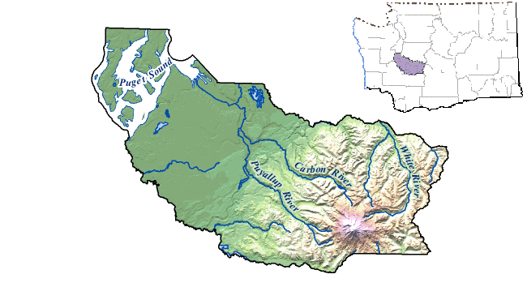
Directions: Draw a dashed line along the approximate ________ River watershed boundary in the relief map above. (fill in with the name of the largest river near your school)
Where does water from precipitation go? ______________________________________________________________________________
______________________________________________________________________________

What can this runoff carry with it downstream to the estuary? ______________________________________________________________________________

Describe one way to prevent excess nutrients and toxins from entering the estuary.
______________________________________________________________________________
Read the following tips for how to be a Salish Sea Hero in your own home!
From Skagit Conservation District Stormwater Pollution flyer:
“Be Part of the Solution to Stormwater Pollution”
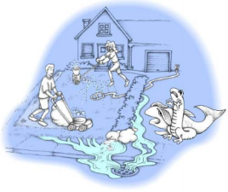
Each time it rains, water washes over our streets, driveways, and yards picking up pollutants along the way and flowing into our storm drains.
This runoff may contain pollutants such as motor oil, yard clippings, pet waste, litter, lawn chemicals, anti-freeze, or other toxins, which can pollute our water supply as well as clog pipes and culverts which can lead to flooding.
Known as “Non-point Source Pollution”, it is the largest threat to our waterways today. Sometimes pollutants are dumped directly into storm drains by neighbors who don’t know any better.
Contrary to popular belief, most storm drains are not connected to treatment systems. Whatever enters the drain is discharged directly, untreated into local waterways!
You can help by using the following tips to prevent pollution:
- Properly dispose of hazardous waste and recycle used motor oil.
- Use fertilizers, pesticides, and herbicides sparingly and follow the manufacturer's instructions.
- Keep yard waste, trash, and dirt off the street and out of the gutters.
- Clean up after your pets by bagging your pets waste and disposing of it in the garbage or it may be flushed.
- Wash your car at a car wash facility or park your car in the grass before you wash it.
Spread the word about protecting our waterways from polluted runoff

