NATURE DETECTIVES: PLANKTON PROS

BACKGROUND FOR PEER PRESENTERS
Plankton are living things that drift in the ocean, swimming too weakly to counteract currents. Some are microscopic, but some are giant. The small ones are the base of all ocean food webs. Plant-like plankton called phytoplankton are also the source of 70% of the oxygen we breathe. With their direct link to food for wildlife (including us!) and our air supply, it is super important to ensure the health of their habitat in the Salish Sea and beyond. Start by getting to know them up close and personal, under a microscope!

You can introduce plankton to your class using these PowerPoint slides. Next, demonstrate to the class how to operate their microscopes, if you have them (ask your teacher to train you ahead of time). If no microscopes are available, you may use hand lenses with high magnification.
Then, show the class where to obtain their plankton samples and microscopy materials. Have the Lab/Field Technicians gather the supplies for their Explore Teams.

MATERIALS
For the class: Plankton net and dock or boat access (if collecting your own plankton)
*1 bucket of plankton in seawater collected by class or provided by a local marine expert. 1-2 large turkey basters for stirring and obtaining samples from the bucket
*See below to make your own plankton net with materials at home and conduct your own plankton tow

For each group: 1 or 2 plastic pipettes (eye droppers)
1 plastic cup to hold the plankton sample
2 dissecting scopes with lights
1-2 petri dishes or microscope slides with a well
1-2 phytoplankton ID guide and 1-2 zoooplankton ID guide (Feiro Marine Life Center)
Colored pencil set
For each student: 1 Activity worksheet

INSTRUCTIONS TO GIVE YOUR PEERS
1. Stir the bucket of plankton with the turkey baster to bring up those that may have sunk to the bottom.
2. Use the turkey baster to transfer plankton water to your plastic sample cup.
3. Use the pipette to add 3-6 drops of plankton sample to petri dish or slide at lab tables.
4. Place slide on microscope stage. Adjust the scope to focus on one plankter at a time.
5. Use guides to identify plankton, sketch 2, and determine type: phyto, zoo, mero, holo.

EXTENSION (Physics and Math Challenge)
Save the Plankton, Breathe Freely by National Geogrphic Education: https://www.nationalgeographic.org/activity/save-the-plankton-breathe-freely/
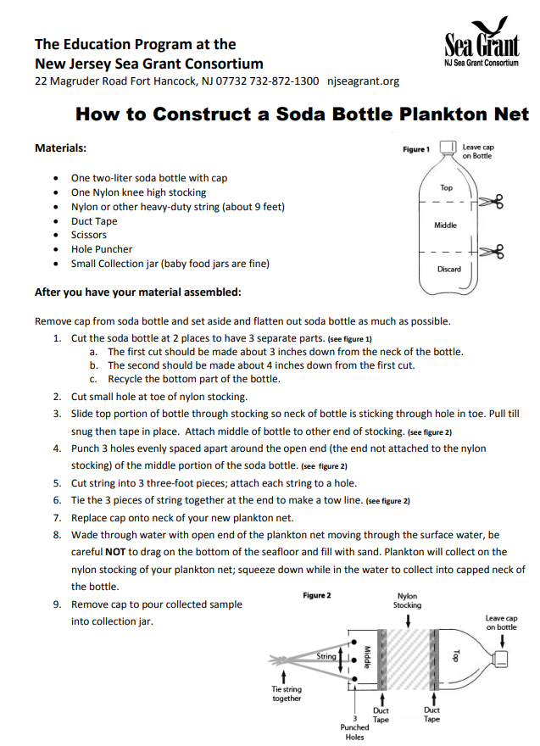
STUDENT WORKSHEETS Name______________________
Activity! Become a Plankton Pro!
*Need to know: *What to do:
*Plankton are living things that swim too weakly to counteract currents. Some are microscopic, but others are as long as a football field!  *Holoplankton remain plankton their whole lives. Meroplankton are merely plankton while young.  *Phytoplankton generate 70% of the oxygen we breathe through photosynthesis! | 1. Collect a sample of plankton from the bucket. Give the water a gentle stir before obtaining your sample (some plankton will sink to the bottom).  2. Use your pipette (eye dropper) to place 3-5 drops of seawater into your microscope slide or petri dish.  3. Place onto your microscope stage and adjust scope for viewing.  4. Choose two plankters to identify and sketch below

My Favorite Plankter #1 My Favorite Plankter #2
Type of plankton: ___________________ Type of plankton: _______________________
Circle: Phytoplankton or Zooplankton? Circle: Phytoplankton or Zooplankton?
Holoplankton or Meroplankton? Holoplankton or Meroplankton?

Look up the meaning of the root word phyte.
Turn and Talk Based on what you learned, where in the water column do you think phytoplankton need to live? ____________________________________________________
Physics and Math Challenge How much of the oxygen you use in one day is provided by phytoplankton? Hint: phytoplankton produce about 330 billion tons per year. Calculate!

