ROCK RAINBOW
BACKGROUND FOR PEER PRESENTERS
Rocks only look still and lifeless. But if you could see a time lapse of their existence, you’d see them building up from eroded sediments and discarded shells, twisting and squishing from heat and pressure deep in the earth, then melting and oozing or blasting from volcanic eruptions, only to solidify and erode again. It’s the rock cycle and it is the supply of a rockstar lineup of rolling stones! Each change yields new types of rock and these come in all shapes, sizes, and a rainbow of colors.
In this lesson you’ll first give students a basic overview of the rock cycle. A few slides with photos of classic examples and the rock cycle should do. Use this video for a further explanation. You can show it to your class before this activity, too.
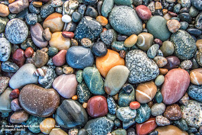
Right here around the Salish Sea, the rock cycle has been hyperactive over the last couple hundred million years. Watch this short video on the Kumtuks vlog to see how it shaped our very own landscapes today. Peruse this University of Washington website to see how geology rocked the Salish Sea! Burke Museum’s New Lands Along an Old Coast: Building the Pacific Northwest
MATERIALS
For you: computer and projector or other audio/visual device, Untamed Science Rock Cycle video, the Geology of British Columbia video, and the weblink for New Lands Along an Old Coast: Building the Pacific Northwest. Set up the computer and projector and open each of the video links you want to show to have them ready at the click of your mouse.
For the class: Several samples (or a beach full) of igneous, metamorphic, and sedimentary rocks of many colors and textures, a large map of the Salish Sea to place rocks on
For each pair: Basic Rock dichotomous key, Explore the Salish Sea A Nature Guide for Kids book, Map of Salish Sea, colored pencils, magnifying glasses or dissecting scopes, apece of glass to scratch with the rock

INSTRUCTIONS TO GIVE YOUR PEERS
1. Tell students that the rock cycle really rocks and we’re going to dig into how it formed the Salish Sea. Show them the Untamed Science Rock Cycle video. Let each student collect one rock (this can be from a supply of sample rocks provided or from a beach trip).
2. Ask the student to fill in the information page about their rock, then turn and talk to their group members about how the rock could have formed and what features it has (1 min for each person).
3. Have students work in Explore Teams to arrange their rocks based on their physical features (such as color, then texture (crystals? Sand? Gravel?), then sediment size if it can be seen (if sedimentary).
4. Have all the students line up their rocks on a table in a similar fashion (color, texture, sediment, etc.) and see what the rock rainbow shows.
5. Next, have each person place his/her rock on the map of the Salish Sea based on how it may have formed. Then look for any similarities to the rock rainbow. What features do certain locations share?

STUDENT WORKSHEETS

Activity! Rock Rainbow
Do you know why rocks have certain characteristics?
Each rock has a story about how and where it formed. By looking at color, texture, and matter in rocks, we can be rock detectives and find out how they came to be.

D Draw your rock here | List of features
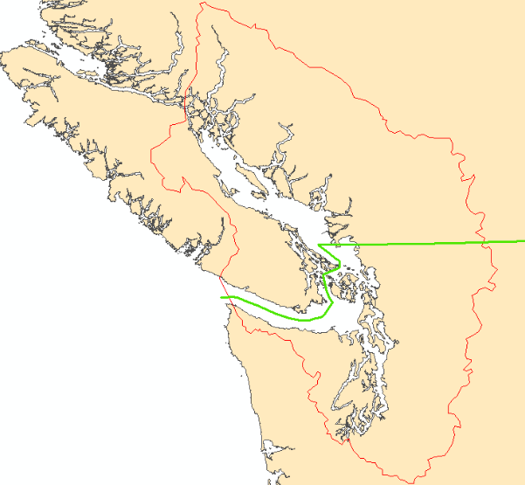 | Guesses about how it was formed

A dichotomous key is a sequence of questions that eliminates possible answers with each 2-option step. Now that you have a guess based on your astute observations, follow this dichotomous key to narrow down your rock to its specific type and identification: THE ROCK KEY by Nevada Bureau of Mines and Geology online or printed version.

