THE WATER CYCLE IN ACTION
BACKGROUND FOR PEER PRESENTERS
Kids usually learn best through hands-on discovery. Let your students discover for themselves what happens in this activity; don’t tell them what they should see ahead of time!

You will explain the following after they conduct the activity and then think and talk about it:
When warm, moist air that is full of water vapor, meets cold air, the water vapor condenses into droplets we can see. It changes state from a gas into liquid. This is how clouds form. If there are particles in the air for the water to stick to, such as the smoke particles in this activity, clouds can form even quicker.

See this video for a quick explanation of the concepts behind cloud formation and how to guide your Weather and Sea activity.

MATERIALS
For each group: 1 glass or plastic jar (Mason jars work well), 4 ice cubes on foil or in a baggie, 1 match (teacher discretion!), boiling water (enough to fill jar ¾ full), hot pad or towel for handling hot jar, Student Worksheets, one per student, and pencils or colored pencils for drawing a diagram of the results.
INSTRUCTIONS TO GIVE YOUR PEERS
Have Explore Teams gather materials, one set per Team and then follow along as you demonstrate the steps of the activity in the front of the room, copying what you do.
1. First, pour boiling water into your jar until it is ¾ full.
2. Next, have an adult light a match and drop it into the water in your jar.
3. Finally, place the ice on top of the jar and observe.
4. Ask Explore Teams to turn and talk about their observations and draw in what happened in the jar in their Student Worksheet diagram.
5. Ask for the Science Communicator from each Team to share Team thoughts on what was happening.
6. Now explain the phenomenon, using vocabulary from your Background for Peer Presenters above, including that this physical process is what drives the water cycle!
7. Have students draw a water drop at each state change on their Water Cycle Diagrams.
8. Ask the class to get up and dance! Lead your class in the Water Cycle Song to help remember the water cycle. Here is an example from a SeaDoc teacher workshop (pretty funny to see teachers and scientists shakin’ it to this song). www.tiny.cc/seadocwatercycle to use as a guide. 9. Finally, have students draw and label their own water cycle diagrams on their worksheets.
STUDENT WORKSHEETS
Do you know what happens when warm water meets cold air? Let’s see.
Activity! Weather and Sea
*Do you know?: *What to do:
*Clouds are made of tiny water droplets.  *Water droplets condense from invisible water vapor (gas) in the air as it cools.  *The water droplets form on tiny particles of dust or smoke in the air. No particles? No condensation.  *Water vapor evaporates from liquid water or sublimates from solid water (ice). | 1. Pour hot water into your jar.  2. Drop a smoking match into the jar.  3. Cover the jar with aluminum foil  4. Cover the foil with ice cubes and watch!  5. Draw your observations here:  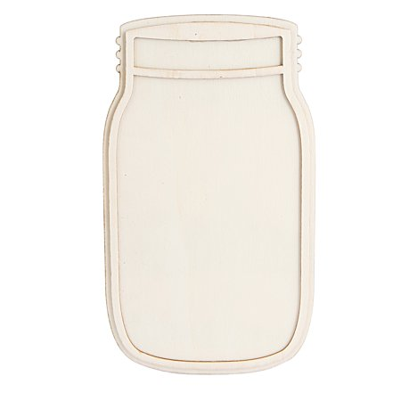

How might the process you observed relate to your local weather this week?
_________________________________________________________________________________________________________________________________________________________________________________________________________

You’ve just seen the water cycle in action!
Did you know water is always on the move? The water cycle involves every change in form (state) and location of every drop of water on the earth, beneath the ground, in the air, and of course, in the ocean? The water you drank today may be the same water that a T-rex drank 83.6 million years ago.
Directions: Draw a water drop at each location where water is changing state from solid to liquid, liquid to gas (water vapor), or the other way around. Where it is really cold, water can even change straight from a solid to a gas (sublimation). Draw a drop there, too.

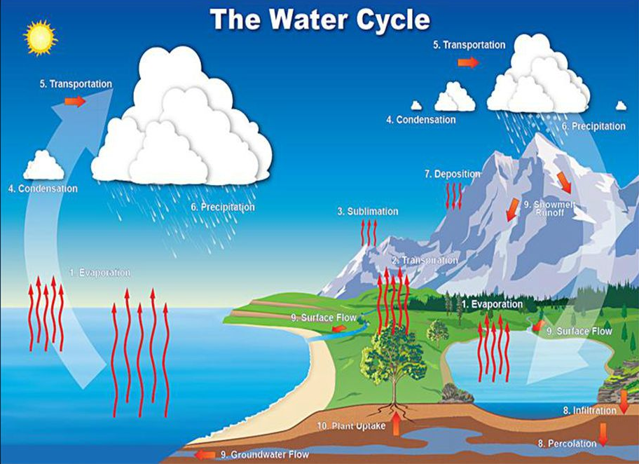

WATER CYCLE SONG
Follow the lead of your peer presenters to get up, sing, and shake it!

Draw your own watercycle diagram here
Label each of the following:
Lake
Sea
Land
Snow and ice
Evaporation
Condensation
Transportation
Precipitation
Saturation

